***Section* 2.5 – Numerical Integration**

**Absolute and Relative Error**

***Definition***

Suppose *c* is a computed numerical solution to a problem having an exact solution *x*.

There are two common measures of the error in *c* as an approximation to *x*:

 & 

***Example***

The ancient Greeks used  to approximate the value of *π*. Determine the absolute and relative error in this approximation to *π*.

***Solution***











**Midpoint Rule**

***Definition***

Suppose  is defined and integrable on . The ***midpoint Rule Approximation*** to  using *n* equally spaced subintervals on  is





Where 



 is the midpoint of , for .

***Example***

Approximate  using the Midpoint Rule with  subinterval

***Solution***

With 

The grid points are:

























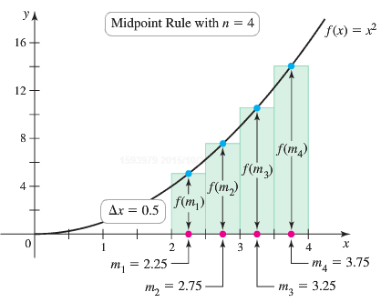















**Trapezoid Approximations**

The ***Trapezoid Rule*** for the value of a definite integral is based on approximating the region between a curve and the *x*-axis with trapezoids instead of rectangles.

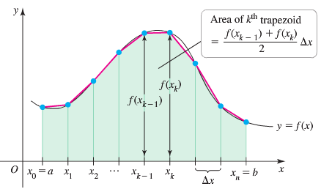

The length of each subinterval is  is called the ***step size*** or ***mesh size***.

The area of a trapezoid: 

The area is the approximation by adding the areas of all trapezoids:







***The Trapezoid Rule***

If  is continuous on [*a, b*] and if a regular partition of [*a, b*] is determined by the numbers , then







Where  and 

***Error Estimate for the Trapezoidal Rule***

If *M* is a positive real number such that  for all *x* in [*a, b*], then the error involved in using the Trapezoidal Rule is not greater than 

***Example***

Use the Trapezoid Rule with *n* = 4 to estimate . Compare the estimate with the exact value.

***Solution***

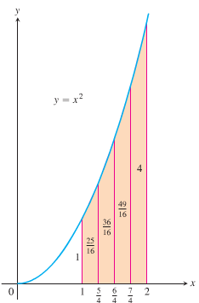

























 

The difference: 

The percentage error: 

***Simpson’s Rule*: Approximations Using Parabolas**

We partition the interval [*a, b*] into *n* subintervals of equal length 

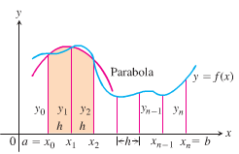 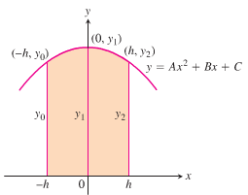

The parabola has an equation of the form: 

So the area under it from *x* = *−h* to *x* = *h* is













Since the curve passes through the three points 











Computing the areas under all the parabolas and adding the results gives the approximation





***Simpson’s Rule***

To approximate , use 



Where 



***Error Estimate for the Trapezoidal Rule***

If *M* is a positive real number such that  for all *x* in [*a, b*], then the error involved in using the Simpson’s Rule is not greater than 

***Example***

Use Simpson’s Rule with *n* = 4 to approximate 

***Solution***















 ***The exact value is* 32**.

***Example***

The table lists rates of change  in global sea level  in various years from 1995  to 2011 , with rates of change reported in *mm/yr*.

|  |  |  |  |  |  |  |  |  |
| --- | --- | --- | --- | --- | --- | --- | --- | --- |
| *Years* | 1995 | 1998 | 2000 | 2002 | 2003 | 2007 | 2009 | 2011 |
| ***t*** | 0 | 3 | 5 | 7 | 8 | 12 | 14 | 16 |
| (*mm/yr*) | 0.51 | 5.19 | 4.39 | 2.21 | 5.24 | 0.63 | 4.19 | 2.38 |

1. Assuming  is continuous on , explain how a definite integral can be used to find the net change in sea level from 1995 to 2011; then write the definite integral.
2. Use the data in the table and generalize the trapezoid Rule to estimate the value of the integral from part (*a*).

***Solution***

1. The net charge in any quantity *Q* over the interval  is 

Net change in  

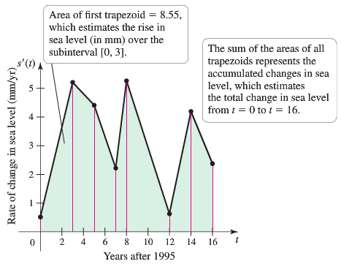

1. From the figure the values accompanied by 7 trapezoids whose area approximates 

***Area*** of the ***first*** trapezoid:















































***Exercises*** ***Section* 2.5 – Numerical Integration**

Find the *Midpoint* Rule approximations to

|  |  |
| --- | --- |
|  |  |

Estimate the minimum number of subintervals to approximate the integrals with an error of magnitude of  by (***a***) the *Trapezoid* Rule and (***b***) *Simpson’s* Rule.

|  |  |  |
| --- | --- | --- |
|  |  |  |

Find the *Trapezoid* & *Simpson’s* Rule approximations and error to

|  |  |
| --- | --- |
|  |  |

|  |  |
| --- | --- |
|  |  |

1. A piece of wood paneling must be cut in the shape shown below. The coordinates of several point on its curved surface are also shown (with units of inches).

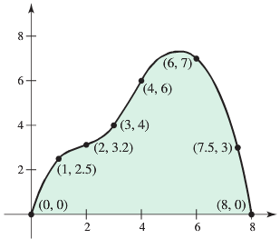

1. Estimate the surface area of the paneling using the Trapezoid Rule
2. Estimate the surface area of the paneling using a left Riemann sum.
3. Could two identical pieces be cut from a 9-*in* by 9*-in* piece of wood?
4. The region bounded by the curves ,  and  is rotated about . Use Simpson’s Rule with  to estimate the volume of the resulting solid.
5. A pendulum with length *L* that makes a maximum angle  with the vertical. Using Newton’s Second Law it can be shown that the period *T* (the time for one complete swing) is given by



Where  and *g* is the acceleration due to gravity. If  and , use Simpson’s Rule with  to find the period.